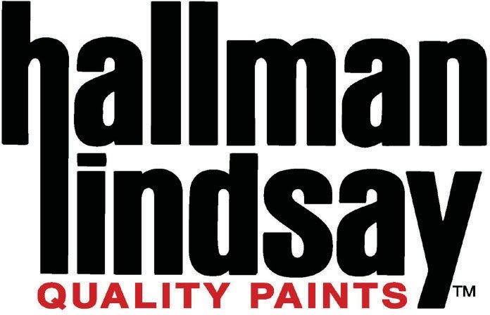

CONTROLLER

Hallman Lindsay Paints, a progressive, rapidly growing Wisconsin-based paint manufacturing company with 33 retail stores, is currently looking for an experienced individual to assist with the overall timeliness and accuracy of the financial reporting. The Controller is responsible for processing payroll; helping with filing taxes; and other miscellaneous tasks related to accounting. This position is also responsible for handlings various disbursements.

This is an exciting opportunity that offers a great deal of growth opportunities for an experienced and self-motivated individual with the desire to take this type of position to the next level!

Primary responsibilities include, but are not limited to:
- Managing all Hallman Lindsay internal and external working relationships in a manner that reflects our corporate values.
- Support management reporting functions for sales, inventory, and store operations.
- Support the monthly financial close process.
- Proofs accounting reports for clerical accuracy.
- Allocates expenditures to correct accounts according to departmental procedures.
- Collaborates in identifying and implementing process and system improvements.
- Helps to oversee accounts payable and general ledger activities.
- Prepares/files sales tax returns and supports other tax filings.
- Maintains knowledge of acceptable accounting practices and procedures.

Required skills and experience:

- Bachelor's degree in accounting or related field.
- Five to seven years in public accounting with a preference for audit experience. Bonus points for experience in a corporate accounting setting after public accounting.
- Exposure to inventory accounting in some capacity required.
- Excellent organizational skills and attention to detail.
- Knowledge of general financial accounting, consolidations, and cost accounting.
- CPA and CMA credentials preferred.
- Knowledge of QuickBooks Online preferred and experience with Cube software a plus.

